

**SOFTWARE ENGINEERING**

2nd Assignment

NAME : SAHA,SHOUMIK

**Prison Management System** ID : 19-39348-1

SECTION : I

|  |  |  |  |
| --- | --- | --- | --- |
| **Feature ID** | **Description** | **Priority** | **Requester** |
| **FE01** | Web based and accessible from devices (with internet connection) such as desktop, laptop, mobile and tablet PCs. | High |  |
| **FE02** | Accessible for every user. (visitors) | High |  |
| **FE03** | Login interface for visitors, Interior Minister,Jailers,Lawyers. | High |  |
| **FE04** | Selecting Language & location based on servicing area. | High |  |
| **FE05** | Easy for visitors to apply for visiting and open a free account for applying. FAQ will be available. | High |  |
| **FE06** | Access to everything for Interior Minister to control over. | High |  |
| **FE07** | Jailers can add entry of visitors but can’t update. | High |  |
| **FE08** | Lawyers will set cases and it will be system recorded if it is updated. | High |  |
| **FE09** | Login times will be system recorded | High |  |

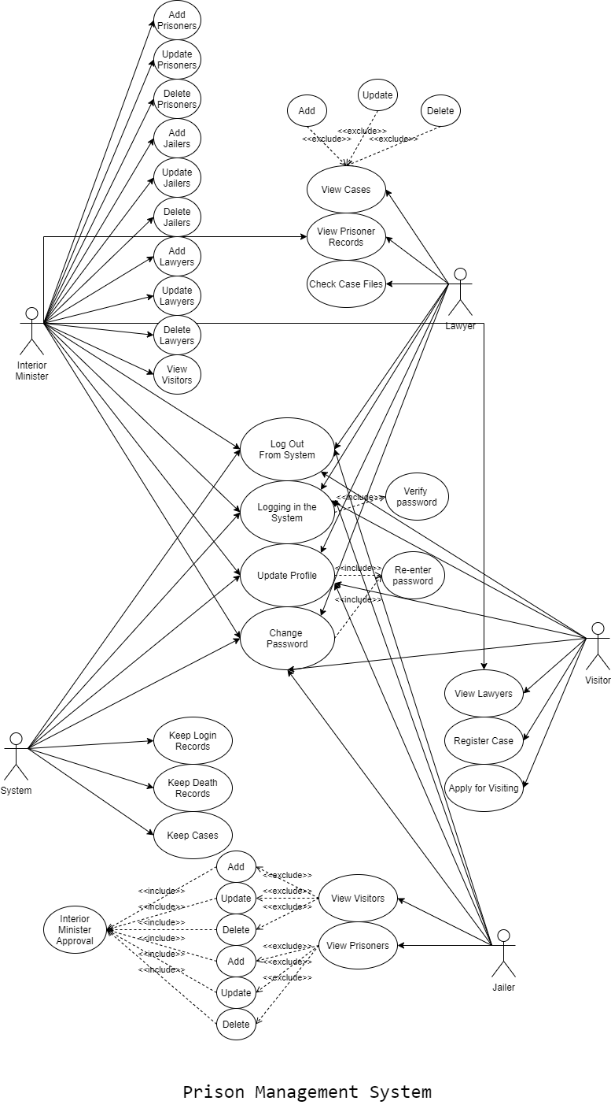

**Use Cases**

|  |  |
| --- | --- |
| **FE02 - Authentication and authorization** | |
| User authentication | |
| **Brief Description** | The user opens up the portal and the portal shows the login form for access. |
| **Pre-condition/s** | * User is not logged in already * User has an account in the system |
| **Priority** | High |
| **Actor/s** | Users of all classes. |
| **Main Success Scenario** | 1. User opens up the web portal 2. The system displays a login form 3. User enters his/her user id and password 4. The system matches user credentials against its date store 5. The system then redirects user to the appropriate page based on user class. |
| **Alternative Scenario** | * The system cannot find a match for the user and re-displays the login form with an error message. * The system runs into internal error (i.e. database unavailable) and notifies user and asks the user to contact administrator |
| **Notes/Questions** | Must need clarification on dashboard for each user type. |

|  |  |
| --- | --- |
| **FE03 - Prisoner data management** | |
| Add,update,delete prisoners | |
| **Brief Description** | Interior Minister wants to add a new prisoners and the system displays form to add prisoners data. |
| **Pre-condition/s** | * Minister must be logged in * Minister must have authorization to add prisoners |
| **Priority** | High |
| **Actor/s** | System, Interior Minister |
|  |  |
|  |  |
| **Notes/Questions** | The system will not store information from incomplete form. A form will be incomplete when all the ‘must be filled’ fields are not filled. |
|  | |
| View Prisoners list | |
| **Brief Description** | The system will display Prisoners information |
| **Priority** | High |
| **Actor/s** | Lawyers,Jailers,Interior Minister |
| **Main Success Scenario** | 1. The prisoners list will be displayed in a single organized page |
| **Alternative Scenario** | * The system is unable to extract Prisoners information from the database and generates error message |
| **Notes/Questions** | The types of views must be mentioned |

|  |  |
| --- | --- |
| **Applying for visiting** | |
| Apply with web | |
| **Brief Description** | The user opens up the portal and the portal shows the login form for access and apply for visiting |
| **Pre-condition/s** | * User is not logged in already * User has an account in the system |
| **Priority** | High |
| **Actor/s** | Visitors |
| **Main Success Scenario** | * 1. Selecting prisoner to request for visiting   2. Fill up form with name,NID,who’s to prisoner etc.   3. Wait for application granted by minister |
| **Alternative Scenario** | * Show error if don’t have portal id * Display a limited time for application to be granted by minister |
| **Notes/Questions** | Must need clarification on dashboard for each user type. |

Non-Functional Requirements:

1. **Performance requirements** The application has to be able to run on any platform. The initial loading time of the application will depend on the operating system and internal hardware.

2. **Safety requirements**  The System will keep records .The database might crash at any time due to virus or operating system failure. Therefore, it is required to take backup of the database on a daily basis.

3. **Security Requirement** This project provides a genuine security to all those individuals who are having their account on the database. To avoid inner problems and frauds, the system will keep a record of an account that how many times it were logged in an in which basis.